**PIZZA SALES SQL QUERIES**

**A. KPI’s**

**1. Total Revenue:**

select

round(sum(total_price)) as Total_Revenue

from pizza_sales;

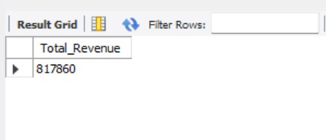

**2. Average Order Value**

select

round(sum(total_price)/ count(distinct order_id),2) as Avg_order_value

from pizza_sales;

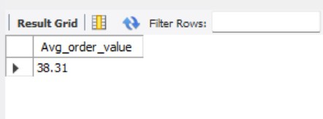

**3. Total Pizzas Sold**

select

sum(quantity) as Total_Pizza_Sold

from pizza_sales;

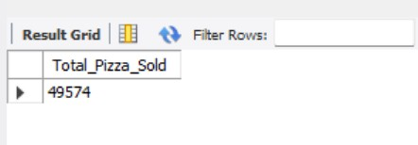

**4. Total Orders**

select

count(distinct order_id) as Total_Orders

from pizza_sales;

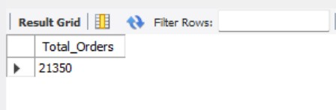

**5. Average Pizzas Per Order**

select

round(sum(quantity)/ count(distinct order_id),2) as Avg_Pizza_per_order

from pizza_sales;

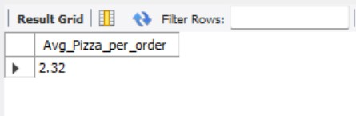

**B. Daily Trend for Total Orders**select

dayname(

case

when order_date like '%/%' then str_to_date(order_date, '%d/%m/%y')

when order_date like '%-%' then str_to_date(order_date, '%d-%m-%y')

else null

end

) as Day_Name,

count(distinct order_id) as total_orders

from pizza_sales

group by 1

order by 2 desc;

***Output:***

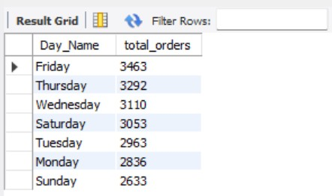

**C. Monthly Trend for Orders**

select

monthname(

case

when order_date like '%/%' then str_to_date(order_date, '%d/%m/%y')

when order_date like '%-%' then str_to_date(order_date, '%d-%m-%y')

else null

end

) as Month_Name,

count(distinct order_id) as total_orders

from pizza_sales

group by 1

order by 2 desc;

***Output***

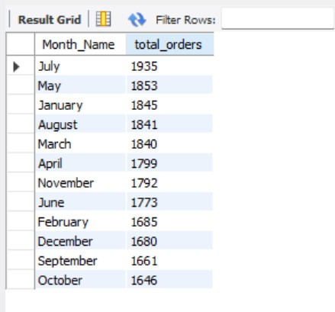

**D. % of Sales by Pizza Category**

select

Pizza_category as Category,

round(sum(total_price)) as Total_Revenue,

round(sum(total_price)*100/ (select sum(total_price) from pizza_sales),2) as PCT

from pizza_sales

group by 1;

***Output***

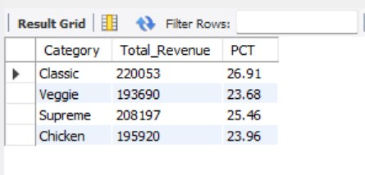

**E. % of Sales by Pizza Size**

select

Pizza_size as Size,

round(sum(total_price)) as Total_Revenue,

round(sum(total_price)*100/ (select sum(total_price) from pizza_sales),2) as PCT

from pizza_sales

group by 1;

***Output***

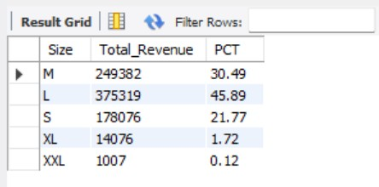

**F. Total Pizzas Sold by Pizza Category**

select

pizza_category as Category,

sum(quantity) as total_quantity_sold

from pizza_sales

group by 1;

***Output***

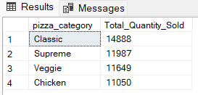

**G. Top 5 Pizzas by Revenue**

select

pizza_name,

round(sum(total_price)) as total_revenue

from pizza_sales

group by 1

order by 2 desc

limit 5;

***Output***

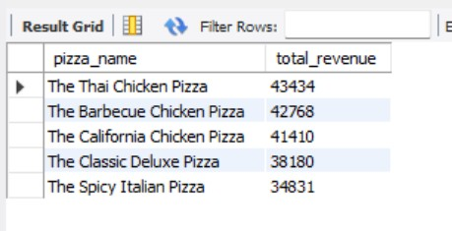

**H. Bottom 5 Pizzas by Revenue**

select

pizza_name,

round(sum(total_price)) as total_revenue

from pizza_sales

group by 1

order by 2

limit 5;

***Output***

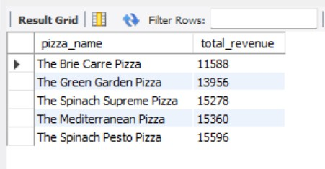

**I. Top 5 Pizzas by Quantity (Using Window Function)**

select

pizza_name,

sum(quantity) as Toatl_Pizza_Sold,

rank() over ( order by sum(quantity) desc) as rank_no

from pizza_sales

group by 1

limit 5;

***Output***

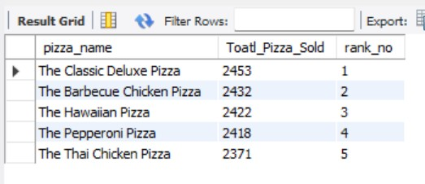

**J. Bottom 5 Pizzas by Quantity (Window function and CTE)**

with ranked_pizzas as

(

select

pizza_name,

sum(quantity) as Toatl_Pizza_Sold,

rank() over ( order by sum(quantity) asc) as rank_no

from pizza_sales

group by 1)

select * from ranked_pizzas

where rank_no <= 5;

***Output***

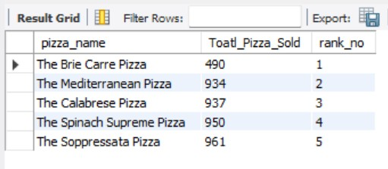

**K. Top 5 Pizzas by Total Orders**

with ranked_pizzas as

(

select

pizza_name,

count(distinct order_id) as Toatl_Orders,

rank() over ( order by count(distinct order_id) desc) as rank_no

from pizza_sales

group by 1)

select * from ranked_pizzas

where rank_no <= 5;

***Output***

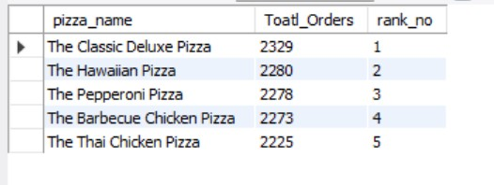

**L. Bottom 5 Pizzas by Total Orders**

with ranked_pizzas as

(

select

pizza_name,

count(distinct order_id) as Toatl_Orders,

row_number() over ( order by count(distinct order_id) asc) as rank_no

from pizza_sales

group by 1)

select * from ranked_pizzas

where rank_no <= 5;

***Output***

